Platte Canyon Fire Protection District

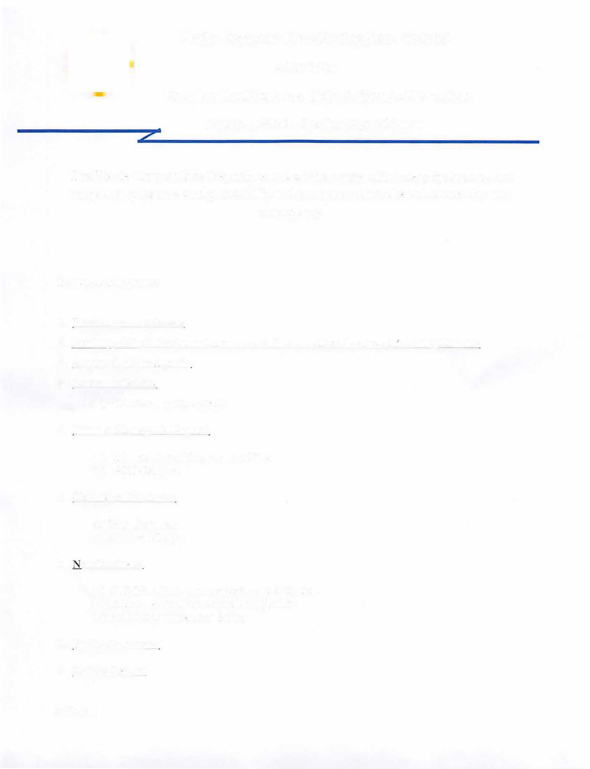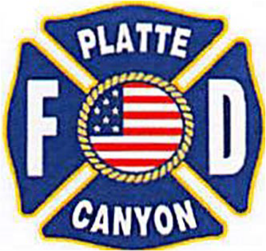

AGENDA

Regular Meeting of the District Board of Directors July 9th, 2024 - Station 2 @7:00 p.m

The Platte Canyon Fire Department is at the ready with integrity, honor, and respect to preserve and protect life and property when the call comes for any emergency.

Pledge of Allegiance

1. Introduction of Guests
2. Reading of the Minutes and Approval of the June Regular Board Meeting Minutes
3. Approval of the Agenda
4. Communications

a.) Scholarship Recipients

1. Finance Manager's Report:
   1. Financials and Payment of Bills
   2. AMB Report
2. Unfinished Business:
   1. Module truck
   2. Accident Policy
3. ew Business:
   1. 2018 Fire Code and Amendment Adoption
   2. Controlled Substance Tracking Policy
   3. Field Pronouncement Policy
4. Public Comment:
5. Chief's Report

Adjourn